HCCS Educational System
(PRE BOARD, 2024)

Time: 1 hour | PRACTICAL BIOLOGY-I 08-04-24 | Total Marks: 15
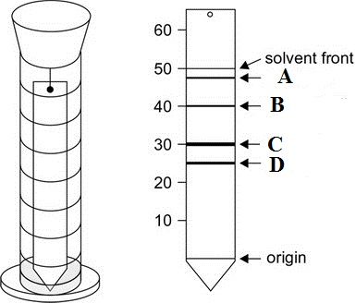
1. Answer the folloiwng questions.
1) Which pigments are shown in A,B,C,and D with colors: (2)
Ans. _________________________________________
_________________________________________
_________________________________________
_________________________________________

2) Calculate the Rf value of B by applying formula as values shown in the diagram.
(2)
Ans. ____________________________________________________________________
________________________________________________________________________
3) Why pigment at region D is located lower than A? (2)
Ans. ____________________________________________________________________
________________________________________________________________________
4) Draw a neat and labelled diagram of a chlorella. (2)


5) Give 4 major characters that clearly helps in identification of specimen: (2)
Ans. _____________________________________
_________________________________________
6) Give 2 main distinguishing features of the phylum of the sample diagram: (1)
Ans. _____________________________________
__________________________________________
7) Identification key for an animal is the presence of unsegmented body, worm like body and pointed ends. (1)
a. Centipede b. Earthworm c. Ascaris d. Planaria
8) Identification key for an animal is the presence of vertebral column, feathers and bill on the body. The animal would be: (1)
a. bird b. Duckbill platypus c. Frog d. Lamprey

9) Name the test used for the indentification of proteins. (1)
Ans :__________________________________________________________
10) Write the floral formual of Rosa indica . (1)
Ans :__________________________________________________________

