
HCCS Educational System
(PRE BOARD, 2024)

Time: 30 Min | PRACTICAL(PINK/BLUE) COMPUTER -I 29-03-24 | Total Marks: 25
Question No.1 15
A computer game shop keeps its stock levels in a database table called GAMES. The fields used in the stock table are shown below:
Name | Description
Game ID | Primary key
Game Name | The name of each game
Age Restriction | The minimum age at which a person is allowed to play each game.
Game Price | The selling price for each game
Number Stock | The quantity of each game currently in stock
On Order | Whether or not each game is on order from the suppliers
Date Last Ordered | The date the most recent order for each game was placed
Game Description | A summary of the contents and purpose of each game

- State the number of fields that are in the table GAMES. 01
_______________________________________________________________________
- State one important fact that must be true for a field to be a primary key. 01
_______________________________________________________________________
- Write the data type which you will select for any of the four fields in the above database table: 02
Name | Data Type
Game ID
Game Name
AgeRestriction
Game Price
Number Stock
On Order
Date Last Ordered
Game Description

- Complete the query-by-example grid to output all the games that have no stock and that are on order with the supplier. Display only the GameID, GameName and Gameprice fields in alphabetical order of the name of the game. 04
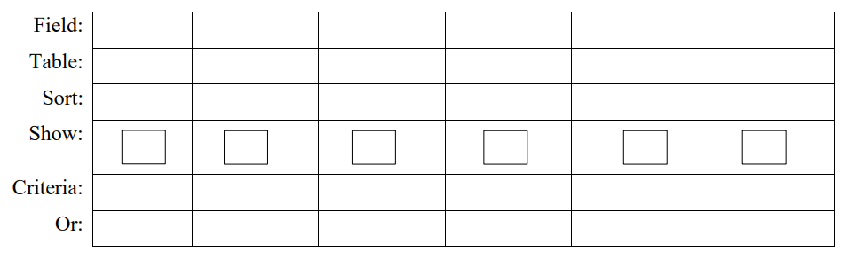
- What will be the output of following query? 04
Field | GameID | GameName | GamePrice | AgeRestriction
Table | GAMES | GAMES | GAMES | GAMES
Sort | Ascending
Show | 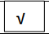 |  |  | 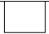
Criteria |  |  |  | >14

- What is the purpose of following dialog box. 03
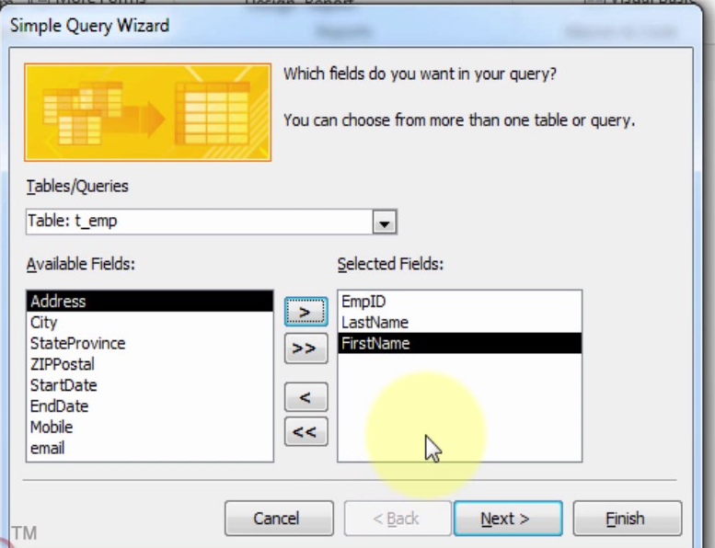

___________________________________

___________________________________

___________________________________

___________________________________

SECTION-B
Question No. 2 10
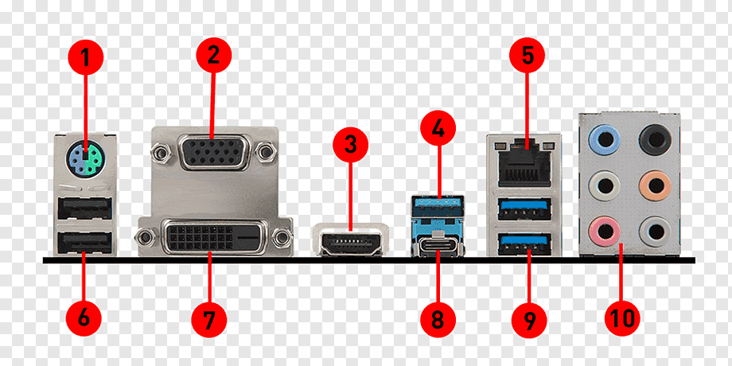
i. The following shows different ports on a computer motherboard. Write the name of 8 ports. 04
No. | Port | No. | Port
1. |  | 5.
2. |  | 6.
3. |  | 7.
4. |  | 8.

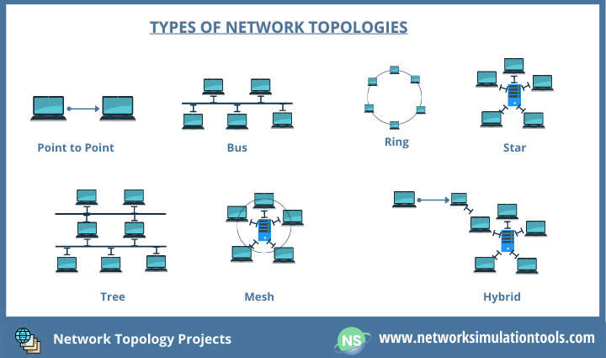
ii. Name the network topologies shown below and write one advantage and one disadvantage. 04

1
2
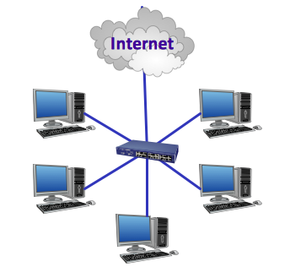


4
No. | Name of the Topology | Advantage | Disadvantage
1.
2.
3.
4.

iii. Complete the step-by-step procedure by filling in the blanks from the given list, to share a folder over the network. 02
(Advance Sharing…, Share this folder, This PC or My Computer, Sharing)
- Open File Explorer: Go to ____________ where you can see all the drives listed.
- Identify the drive you wish to share. Right-click on it and select properties.
- In the properties dialog, navigate to the ____________ tab.
- Click on _______________ button in the sharing tab.
- In the Advance sharing window, check the box labeled ___________________.

