  VERSION NO.
  0 | 0 | 0 | 9
  
  
   |  |  | 
  
  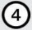
  
  
  
  
  
  ROLL NUMBER


Name of candidate__________________

Sign. of Candidate_________________

Sign. of Invigilator_________________

BIOLOGY (HSSC-II)
SECTION –A (Marks: 17) Time Allowed: 25 Min
Note: Section – A is compulsory. All parts of this section are to be answered on this page and handed over to the Centre Superintendent. Deleting/overwriting is not allowed. Do not use lead pencil.

Q.1 Fill the relevant bubble for each part. Each part carries one mark.
 | Questions | A | B | C | D | A | B | C | D
1. | If allelic frequencies of dominant & recessive alleles is 0.7 & 0.3 respectively then frequency of heterozygous will be? | 0.49 | 0.9 | 0.21 | 0.42 | 
2. | Which will be at the first tropic level? | Grass | Snake | Eagle | Grasshopper
3. | Following is the gel pattern taken from Sangar‘s method of DNA sequencing. Read the sequence given in the gel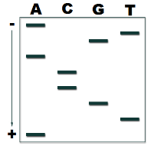 | 5′-ATGCCAGTA-3’ | 3′-TACGGTCAT-5′ | 5′-ATGACCGTA-3’ | 3′-ATGCCAGTA-5′
4. | If father is suffering with hemophilia B, but mother is carrier, then what percentage of their daughters will be patient of hemophilia B? | 25% | 50% | 100% | 75%
5. | Sperm are discharged outside body via: | Urinogenital duct | Epididymis | Sperm duct | Seminiferous
6. | Final preparation of uterus to make it receptive for implantation of zygote is due to: | Estrogen | Progesterone | FSH | Oxytocin
7. | One which has striated muscles: | Esophagus | Rectum | Trachea | None of these
8. | The bone that is present immediately above the ear is: | Occipital | Temporal | Parietal | Ethmoid
9. | The foetus portion of placenta is derived from __________ layer? | Amnion | Chorion | Allantois | None of these
10. | Which of the following muscles is exclusively under nervous control? | Smooth muscles | Skeletal muscles | Cardiac muscles | All of these
11. | Which is regulated by steroid level of blood: | ACTH | Cortisol | Progesterone | All of these
12. | Permeability for water is increased by ADH at: | DCT | Both a & b | CD | None of these
13. | Group of ribosomes associated with RER in neurons are | Polysome | Cisternae | Polyribosome | Nissl’s Granules
14. | During 4th month of human development ________ are formed: | Sensory organ | Difference between sexes | Bone replacing cartilage | None of them
15. | A female will suffer from hypophosphatemic rickets if she is: | Homozygous dominant | Homozygous recessive | Hemizygous dominant | Hemizygous recessive
16. | The capacity of Hb to hold oxygen becomes less when: | CO₂ is low | H concentration is low | Temperature is low | Blood pH is low
17. | Bacteria convert nitrites to nitrates | Pseudomonas | Rhizobium | Nitrobacter | Nitrosomanas


HCCS EDUCATIONAL SYSTEM
BIOLOGY HSSC II
(PRE BOARD EXAM, 2024)
(SUBJECTIVE)
Time allowed: 2:35 Hours Total Marks Section B and C: 68
Note: The Questions of sections B and C are to be answered on the separately provided answer book. Use supplementary answer sheet i.e. sheet – B if required. Write your answers neatly and legibly.
SECTION – B (42 Marks)
Q.2 Attempt all parts. All parts carry equal marks. (14 x 3 = 42)
1. Write a short note on latent learning with an example
OR
Discuss any three causes of female infertility?
2. In a particular family, one parent has Type A blood, the other has Type B. They have four children. One has Type A, one has Type B, one has Type AB, and the last has Type O. What are the genotypes of all six people in this family?
OR
A man and a woman, both of normal vision, have the following offspring:
A). A color-blind son who then has a daughter with normal vision
B). A daughter with normal vision who later has one color-blind son and one normal son.
C). A daughter with normal vision who later has five sons, all normal
What are the probable genotypes of the original couple, their children, and their grandchildren?
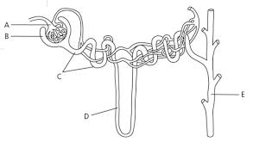
3. Given diagram showing the functional unit of kidney

- Identify the parts A, B, C, D and E
- Name the parts responsible for glomerulus filtration and counter current multiplier mechanism
- Describe the process of counter current multiplier mechanism

OR
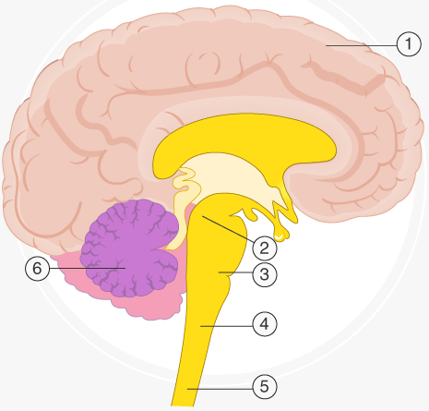
Given diagram showing parts of brain
- Identify parts 1, 3, 4 & 5 (01)
- Write down the functions of parts 1, 6 and 4 (02)

4. Discuss hormonal control of male reproductive system ?
OR
What are sex limited and sex influenced traits?
5. Differentiate between sympatric and allopatric speciation?
OR
How acclimatization and selection techniques are helpful for crop improvements?

6. Explain briefly about the XX-XY type sex determination?
OR
What is umbilical cord? What is its structure and role?
7. What is fate of germs layers in embryonic development?
OR
How is Genomic Library constructed?
8. What is Cystic Fibrosis? How does gene therapy help to cure the disease?
OR
Discuss about the structure of termination region of transcription?

9. Compare protein synthesis in eukaryotes and prokaryotes.
OR
Discuss problems associated with under and over secretions of ADH?
10. Explain the structure and function of alveoli?

OR
Give problems related to abnormal secretion of calcitonin?
11. Give the blood circulation to nephron?
OR
Discuss structure and role of vertebral column?
12. Give differences between afferent and efferent Neurons?
OR
Write causes of miscarriage.
13. Compare holoblastic and meroblastic cleavage?
OR
How process of water treatment take place?
14.Compare anchorage dependent and anchorage independent tissue culture?
OR
What is the difference between Epistasis and Dominance?
SECTION – C (26 Marks)
NOTE: Attempt all questions. All questions carry equal marks.
Q. 3 Write detail note on stages of xerach succession?
OR
What is meant by sex linkage? Explain sex linkage in Drosophila
Q4. Write detail note on menstrual cycle with help of graph?
OR
Write detail note on procedure of Recombinant DNA technology?

Q5. Discuss gastrulation in human??
OR
Give post-transcriptional modifications of mRNA?
Q6. Discuss the polarization process of Neuron?
OR
Discuss procedure of in vitro fertilization?

